Name: ……………………………………..…………Admission No: ………………
Class: …………………………………………..…….....Date: ………………………

SULIMO JOINT EXAMINATION -2025
Kenya Certificate of Secondary Education
231/3
BIOLOGY
Paper 3
JULY 2025
TIME: 1hr45 minutes

INSTRUCTIONS TO CANDIDATES
- Write your name, Admission number and name of your school in the spaces provided above
- This paper consists of three questions
- Answer all the questions in the spaces provided.
- You are required to spend the first 15 minutes of the 1³/₄ Hours allowed for this paper reading through all the questions before commencing your work.
- Candidates should check to ascertain that all pages are printed as indicated and that no questions are missing.

For Examiners Use Only
Question | Maximum score | Candidate’s score
1 | 14
2 | 14
3 | 12
Total Score | 40

- (I). You are provided with a specimen labeled Q (Citrus fruit).
- Using a scalpel cut a transverse section of the specimen Q and retain the other half-portion for part (II) below .Draw and label the exposed surface of the section ( 3marks)

b) What type of fruit is specimen Give a reason ( 2 marks)
…………………………………………………………………………………
………………………………………………………………………………… …………………………………………………………………………………
c) Name the type of placentation exhibited in specimen Q ( 1 mark)
…………………………………………………………………………………
(II). You provided with Liquid L
- Put about 3ml of liquid L in a clean test tube
Add equal amount of Benedict’s solution and heat to boil
Record your observations and conclusions in the table below (2marks)
Observation | Conclusion
- Using the other portion of specimen Q squeeze the juice and sieve it into an empty beaker. Tie one end of a visking tube tightly and pour the sieved juice from the open end then tie to avoid any leakage .Rinse with running water .immerse the visking in liquid L in the beaker and allow it to stand for 30 minutes.
Using the reagent provided carry out food test on the contents in Liquid L
(3 marks)
Food substance | Procedure | Observation | Conclusion
- Account for the conclusion made during the experiment ( 2marks)
…………………………………………………………………………………
…………………………………………………………………………………
…………………………………………………………………………………
…………………………………………………………………………………
- What physiological process was being investigated ( 1mark)
…………………………………………………………………………………
2. A). You are provided with bones E,F and Examine them carefully and answer the
questions that follow

- Identify the bones E, F and G. ( 3 marks)
E …………………………………………………………………………………
G …………………………………………………………………………………
F …………………………………………………………………………………
- State the adaptations of the bone labeled E (2marks)
…………………………………………………………………………………
………………………………………………………………………………… …………………………………………………………………………………
…………………………………………………………………………………
- Identify the joint formed between bone E and F ( 1marks)
…………………………………………………………………………………
B). Study the photograph bellow and answer the questions that follows.

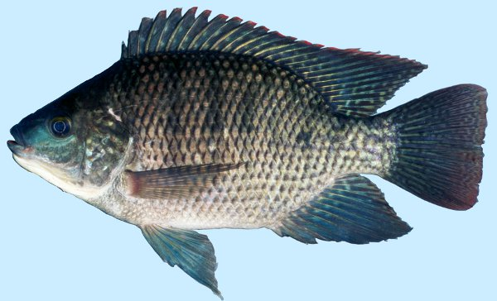

- . Name the class to which the organism represent. (1mark)
…………………………………………………………………………………
- Give two reasons to support your answer in (a) above. (2marks)
…………………………………………………………………………………
…………………………………………………………………………………
…………………………………………………………………………………
(c). Identify the structures that:
(i). Reduces friction. (2marks)
…………………………………………………………………………………
…………………………………………………………………………………
…………………………………………………………………………………
(ii).Control pitching (2marks)
…………………………………………………………………………………
…………………………………………………………………………………
(iii). Detect minute vibrations in water. (1mark)
…………………………………………………………………………………
…………………………………………………………………………………
- The photographs below represents the specimen labeled M, N and P.
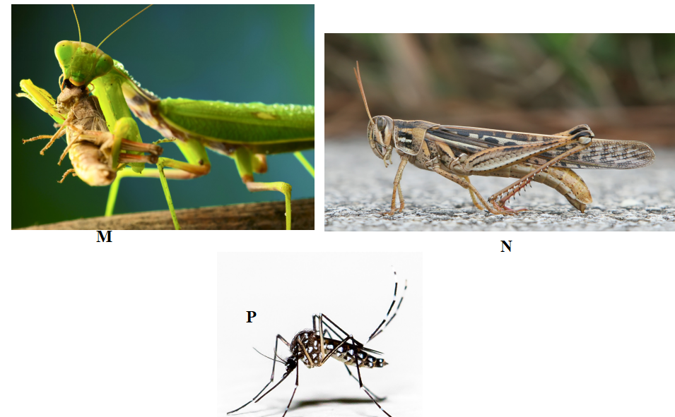
i). Name With a reason the phylum and class to which specimen M, N and P. represent.
Phylum. (1mark) …………………………………………………………………………………
Reason. (1mark) …………………………………………………………………………………
Class ( 1mark)
………………………………………………………………………………….
Reasons. (2marks) …………………………………………………………………………………. …………………………………………………………………………………. ………………………………………………………………………………….
ii) State two observable differences between specimen N and P (2marks)
P | N
iii). Name the mode of feeding exhibited by specimen M giving a reason.
(2marks)
Mode of feeding.
.....................................................................................................................................................................................................................................................
Reason
..........................................................................................................................................................................................................................................................
iv). What is the name given to the openings on the abdominal parts of specimen N and state how they are adapted to perform their function. (3marks)

…………………………………………………………………………………
…………………………………………………………………………………
…………………………………………………………………………………
…………………………………………………………………………………

